* 1. **配置信息**

配置信息仅配置普通地址通道，格式如下：

表格 6 配置信息格式

|  |  |  |  |  |  |  |  |  |  |  |  |  |  |  |  |
| --- | --- | --- | --- | --- | --- | --- | --- | --- | --- | --- | --- | --- | --- | --- | --- |
| CFG_0 | | | | | | | | | | | | | | | |
| 31 | 30 | | | | 29 | | | 28 | | | 27 | | | 26 | |
| third_req | stream | | | | Broadcast | | | Row/Column | | | Read/Write | | | D2D_FLAG | |
| 25:23 | 22:20 | | | | 19:17 | | | 16:8 | | | 7:5 | | | 4:0 | |
| reserved | ch_cluster_num | | | | reserved | | | Vr_id | | | 3’d0 | | | ddr_channel_id | |
| CFG_1 | | | | | | | | | | | | | | | |
| 31:24 | | | 23:16 | | | | | | 15:8 | | | | 7:0 | | |
| ch_data_pos3_1st | | | ch_data_pos2_1st | | | | | | ch_data_pos1_1st | | | | ch_data_pos0_1st | | |
| CFG_2 | | | | | | | | | | | | | | | |
| 31:24 | | | 23:16 | | | | | | 15:8 | | | | 7:0 | | |
| ch_data_pos7_1st | | | ch_data_pos6_1st | | | | | | ch_data_pos5_1st | | | | ch_data_pos4_1st | | |
| CFG_3 | | | | | | | | | | | | | | | |
| 31:24 | | | 23:16 | | | | | | 15:8 | | | | 7:0 | | |
| ch_addr_pos3_1st | | | ch_addr_pos2_1st | | | | | | ch_addr_pos1_1st | | | | ch_addr_pos0_1st | | |
| CFG_4 | | | | | | | | | | | | | | | |
| 31:24 | | | 23:16 | | | | | | 15:8 | | | | 7:0 | | |
| ch_addr_pos7_1st | | | ch_addr_pos6_1st | | | | | | ch_addr_pos5_1st | | | | ch_addr_pos4_1st | | |
| CFG_5 | | | | | | | | | | | | | | | |
| 31:30 | | | | | | 29:0 | | | | | | | | | |
| Reserved(2) | | | | | | ch_start_addr | | | | | | | | | |
| CFG_6 | | | | | | | | | | | | | | | |
| 31:30 | | 29:16 | | | | | | | | 15:0 | | | | | |
| Reserved(2) | | ch_column_num_1st | | | | | | | | ch_row_num_1st | | | | | |
| CFG_7 | | | | | | | | | | | | | | | |
| 31:30 | | 29:16 | | | | | | | | 15:0 | | | | | |
| Reserved(2) | | ch_column_num_2nd | | | | | | | | ch_row_num_2nd | | | | | |
| CFG_8 | | | | | | | | | | | | | | | |
| 31:24 | | | | 23:21 | | | | | | | | 20:18 | | | |
| Reserved(2) | | | | ch_ data_pos7_2nd | | | | | | | | ch_data_pos6_2nd | | | |
| 17:15 | | | | 14:12 | | | | | | | | 11:9 | | | |
| ch_data_pos5_2nd | | | | ch_data_pos4_2nd | | | | | | | | ch_data_pos3_2nd | | | |
| 8:6 | | | | 5:3 | | | | | | | | 2:0 | | | |
| ch_data_pos2_2nd | | | | ch_data_pos1_2nd | | | | | | | | ch_data_pos0_2nd | | | |
| CFG_9 | | | | | | | | | | | | | | | |
| 31:24 | | | | 23:21 | | | | | | | | 20:18 | | | |
| Reserved(2) | | | | ch_addr_pos7_2nd | | | | | | | | ch_addr_pos6_2nd | | | |
| 17:15 | | | | 14:12 | | | | | | | | 11:9 | | | |
| ch_addr_pos5_2nd | | | | ch_addr_pos4_2nd | | | | | | | | ch_addr_pos3_2nd | | | |
| 8:6 | | | | 5:3 | | | | | | | | 2:0 | | | |
| ch_addr_pos2_2nd | | | | ch_addr_pos1_2nd | | | | | | | | ch_addr_pos0_2nd | | | |
| CFG_10 | | | | | | | | | | | | | | | |
| 31:30 | | | | | | | 29:0 | | | | | | | | |
| Reserved(2) | | | | | | | ch_circu_times | | | | | | | | |
| CFG_11 | | | | | | | | | | | | | | | |
| 31:30 | | | | | | | 29:0 | | | | | | | | |
| Reserved(2) | | | | | | | ch_col_addr_burst | | | | | | | | |
| CFG_12 | | | | | | | | | | | | | | | |
| 31:30 | | | | | | | 29:0 | | | | | | | | |
| Reserved(2) | | | | | | | ch_row_addr_burst | | | | | | | | |
| CFG_13 | | | | | | | | | | | | | | | |
| 31:30 | | | | | | | 29:0 | | | | | | | | |
| Reserved(2) | | | | | | | ch_2nd_addr_burst | | | | | | | | |
| CFG_14 | | | | | | | | | | | | | | | |
| 31:30 | | | | | | | 29:0 | | | | | | | | |
| Reserved(2) | | | | | | | ch_access_length | | | | | | | | |
| CFG_15 | | | | | | | | | | | | | | | |
| 31: 0 | | | | | | | | | | | | | | |
| Reserved(2) | | | | | | | | | | | | | | |

表格 7 配置信息说明

|  |  |  |
| --- | --- | --- |
| 配置信息 | 位宽 | 说明 |
| third_req | 1 | 是否三方请求。 0–否 1–是 |
| stream | 1 | 是否流请求。 0–否 1–是 |
| Broadcast | 1 | 是否广播。 0–否 1–是 |
| Row/Column | 1 | 行/列请求。 0–列 1–行 |
| Read/Write | 1 | 读/写请求。 0–读 1–写 |
| D2D_FLAG | 1 | 数据从DDR到DDR使能信号 |
| ch_cluster_num | 3 | 通道簇数目 |
| Vr_id | 9 | 主控制器虚拟寄存器编号 |
| ddr_channel_id | 5 | 地址通道编号 |
|  | | |
| ch_data_posx_1st | 8 | 目标节点的一级坐标 |
| ch_data_posx_2nd | 3 | 目标节点的二级坐标 |
| ch_addr_posx_1st | 8 | 三方节点的一级坐标 |
| ch_addr_posx_2nd | 3 | 三方节点的二级坐标 |
|  |  |  |
| ch_start_addr | 30 | 起始地址 |
| ch_column_num_1st | 14 | 一级矩阵列 |
| ch_row_num_1st | 16 | 一级矩阵行 |
| ch_column_num_2nd | 14 | 二级矩阵列 |
| ch_row_num_2nd | 16 | 二级矩阵行 |
| ch_circu_times | 30 | 矩阵循环次数 |
| ch_col_addr_burst | 30 | 一级矩阵列加一地址跳变数目 |
| ch_row_addr_burst | 30 | 一级矩阵行加一地址跳变数目 |
| ch_2nd_addr_burst | 30 | 二级矩阵行加一地址跳变数目 |
| ch_access_length | 30 | 二级矩阵大小 |

* 1. **请求信息**

请求信息如下：

表格 8 配置网络请求信息格式

|  |  |  |  |  |  |
| --- | --- | --- | --- | --- | --- |
| REQ_0 | | | | | |
| 31 | 30:24 | | | | |
| End_flag | reserved | | | | |
| 23:22 | 21:20 | | 19 | | 18:16 |
| reserved | Src_type | | reserved | | offset_pos |
| 15:8 | | | | | |
| Local_pos | | | | | |
| 7:0 | | | | | |
| Status_dst_pos | | | | | |
| REQ_1（1） | | | | | |
| 31 | | 30 | | 29:16 | 15:0 |
| 1’b0 | | Last_trans | | ddr_1st_col_pos | ddr_1st_row _pos |
| REQ_1（2） | | | | | |
| 31 | | 30:20 | | 19:0 | |
| 1’b1 | | reserved | | Mc_addr | |
| REQ_2 | | | | | |
| 31:0 | | | | | |
| reserved | | | | | |

End_flag: 1’b0 not end 1’b1 end

Src_type: 2’b01 src_A //top 256 2’b10 src_B //btm 512

1. **状态网络接口模块**

状态网络端口返回簇状态信息：

|  |  |  |  |  |  |
| --- | --- | --- | --- | --- | --- |
| status_0 | | | | | |
| 31 | 30:19 | 18:16 | | 15:8 | 7:0 |
| 1’b0 | reserved | offset_pos | | ddrport_pos | Status_dst_pos |
| status_1 | | | | | |
| 31:8 | | | 7:0 | | |
| reserved | | | ddr_pcc_port_pos | | |
| status_2 | | | | | |
| 31:0 | | | | | |
| reserved | | | | | |

返回给主控制器的状态信息：

|  |  |  |  |  |
| --- | --- | --- | --- | --- |
| status_0 | | | | |
| 31 | 30:17 | 16:8 | 7:5 | 4:0 |
| 1’b1 | reserved | VR_ID | Cluster_type | ddr_channel_ID |
| status_1 | | | | |
| 31:0 | | | | |
| reserved | | | | |
| status_2 | | | | |
| 31:0 | | | | |
| reserved | | | | |

VR_ID：只有DDR发送此字段，表示虚拟寄存器编号。

Cluster_type：功能单元类型 3’b000 VR 3’b001 RCU 3’b010 FFT

3’b011 COP 3’b100 FR 3’b101 ETH

ddr_channel_ID：功能单元编号，对DDR是地址通道编号。

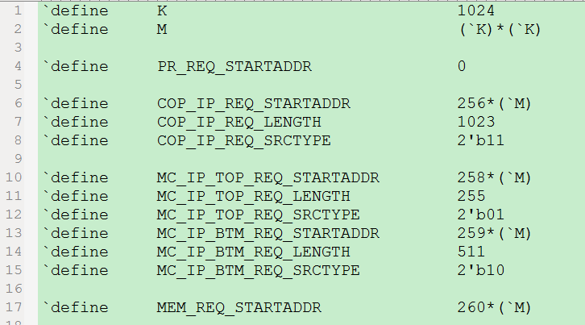

**地址空间分配**

* COP_IP指令存储地址：256M 🡪 (258M-1)

空间尺寸：2M

* MC_IP指令存储地址： 258M 🡪 (260M-1)

空间尺寸：2M

其中，指令分为两类：TOP（顶层指令）、BTM（底层指令），各占1M

TOP： 258M 🡪 (259M-1)

BTM： 259M 🡪 (260M-1)

* 数据存储起始地址 ： 260M 🡪 ……

空间尺寸：不确定

**Ip核数量估计**

* COP不超过16个
* MC 有且仅有1个
* 其他cluster数量待定
* 一个很关键的点

新一版的配置信息，将所有的请求在类型方面分为了三部分：MC指令请求、COP指令请求、所有的数据请求。

地址通道也有所调整，分为了三部分：MC指令请求通道、COP指令请求通道、32个数据请求通道。

数据通道也有所调整，理由：与上一版信息相比，系统要求当DDR的数据请求的某个cluster的所有访存请求完成后，DDR必须向MC上传状态信息，告诉MC当前DDR地址通道的工作情况，以便MC回收资源，同时也是任务切换判断的根本条件。

该状态信息包括来自配置信息中的几条子信息：

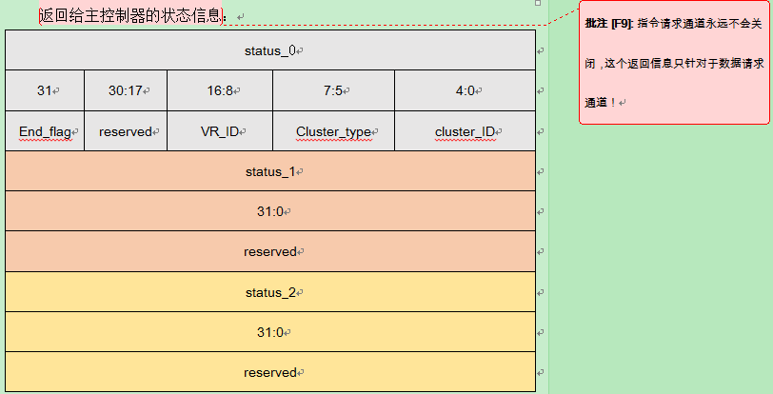

这几条子信息必须随着有效的访存请求以及一级坐标、二极坐标等请求信息一同送入数据通道中，以便在满足发送cluster_release状态信息的时候，将这些子信息准确的传递到状态上传模块。同时我们可以发现，发送cluster_release状态信息的时机也需要地址通道来产生部分辅助信号。

* 数据请求地址通道

需要兼顾以下功能：

-------------------------------

1. 三方、非三方
2. 广播、非广播

-------------------------------

解决方案：

-------------------------------------------

对于Q1，对数据通道无区分，对于地址通道来说，初步设想，使用两个8位的寄存器来分组对应8对三方功能中的“三方节点坐标的请求有效标志” && “目标节点坐标的请求有效标志”。另外增加

对于Q2，需要将广播标志位送到数据通道中，从而决定是从PCC网还是广播网传递数据

-------------------------------------------